GITHUB
Git is a version control system. It tracks changes to our files and project over time.
Github allows us to share our repositories with our team member, we can publish things online and collaborate on open source projects.
For e.g photoshop. You can make photoshop project, you might wanna collaborate with somebody. You put it on dropbox then they download it and they work on it.
Then you download their work and you work on it.
Git is the main technology , github is the platform for to collaborate,share.
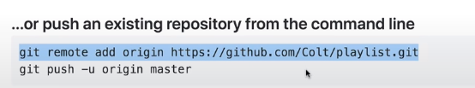

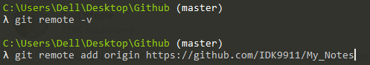

Origin is a standard name, if u creating the first remote.
Now, you can push or retrieve code from remote repository.
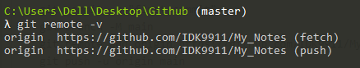

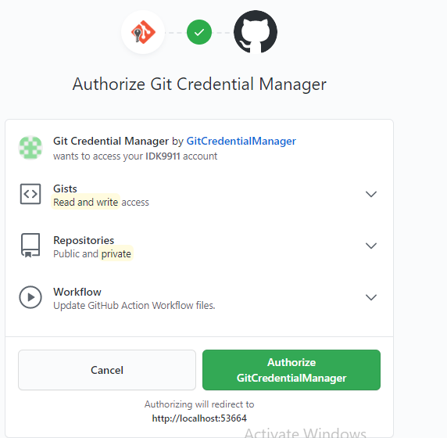

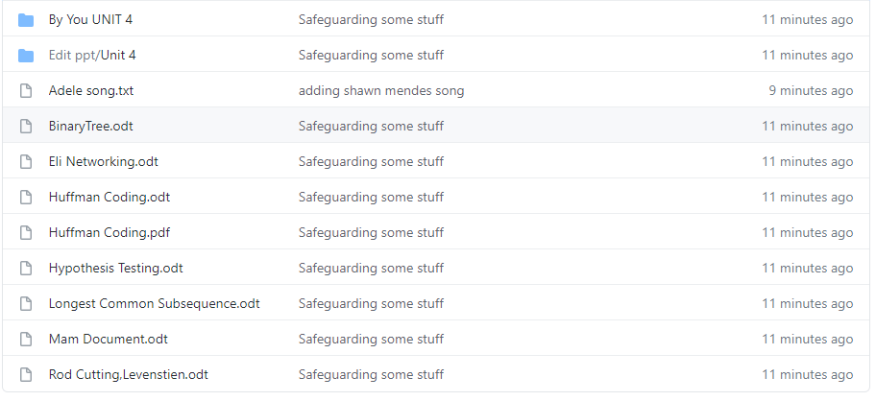
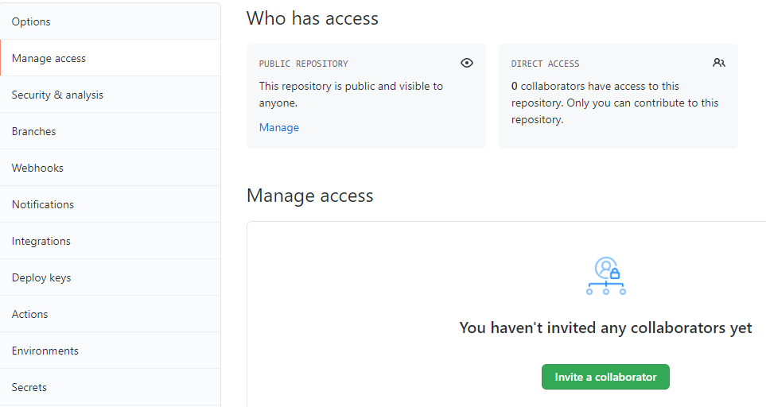
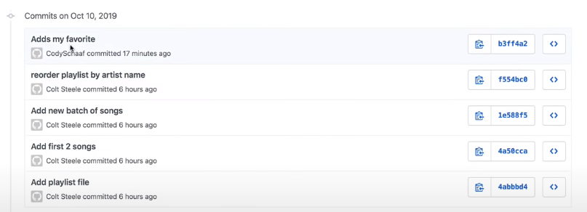

So the collaborator “cody” made changes.
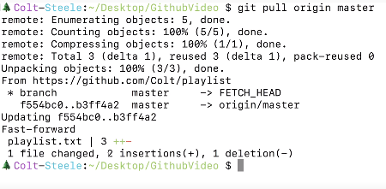

Now you open the file and see the changes cody made.
Working with different branches
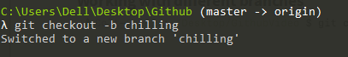

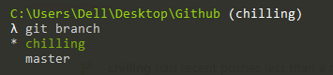
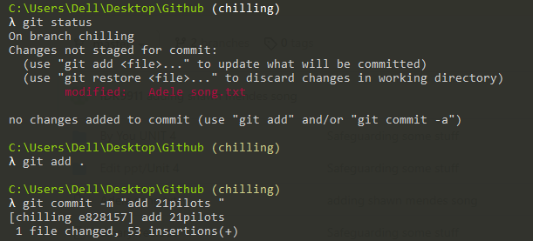

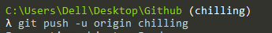
To push the branch on github, along with its contents.

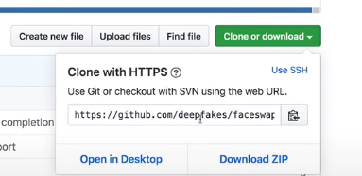

Dont clone a repositories into another repository, so create a new 1.
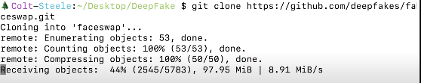

its gonna fetch all the commit history, the git history, everything.
Somebody random cant push his changes to your work, he needs to be a collabortor, which he is to gain access from you.
What you can do is make a pull request.
What you can do is fork a repository. This makes you a own copy on github. So it takes the exact current state of this repository and makes it own version and you have the permission to do whatever you want to that version.
So you make the changes and push to your version or fork.
Then you can make a request to the Somebody and gave a explanation on github. They can reject it or accept it.
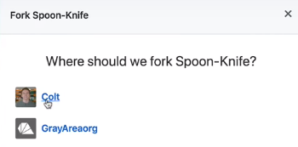

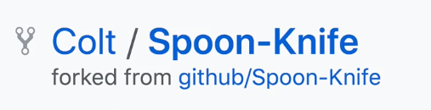

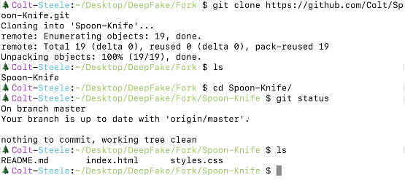

So you next push the changes on your git and then github
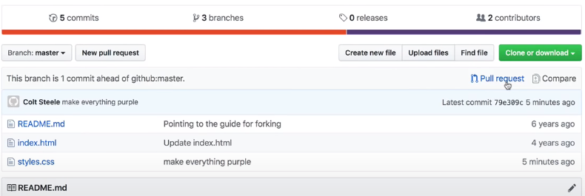

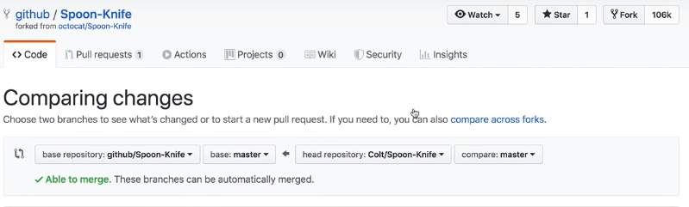
You gonna make a pull request
It now says, github/spoon-knife. Instead of colt/spoon-knife.
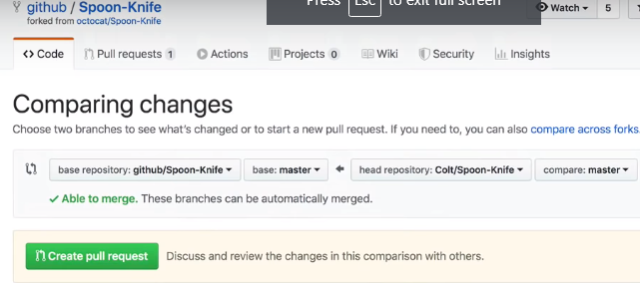
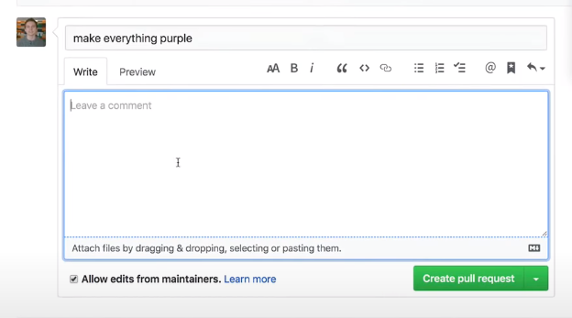

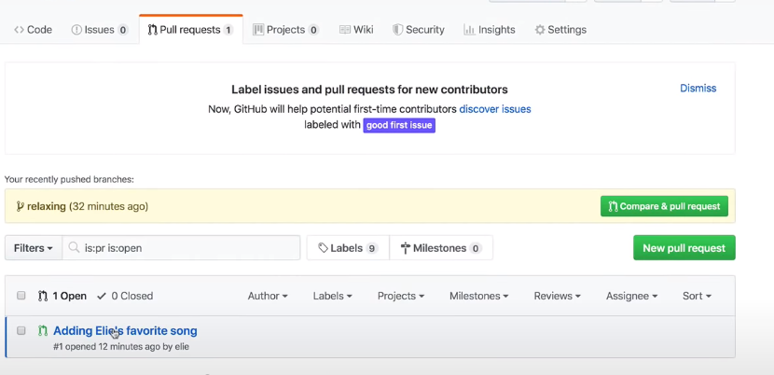
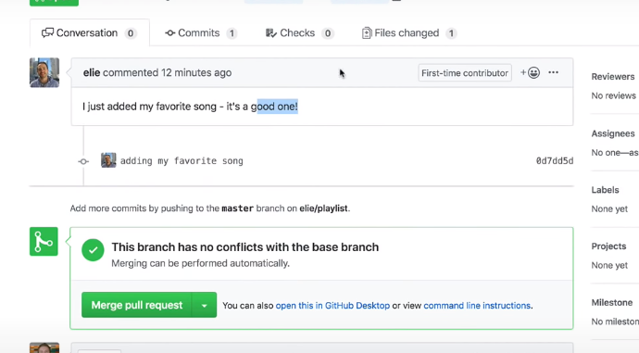

We can look what changes he has done, we can go to commit.
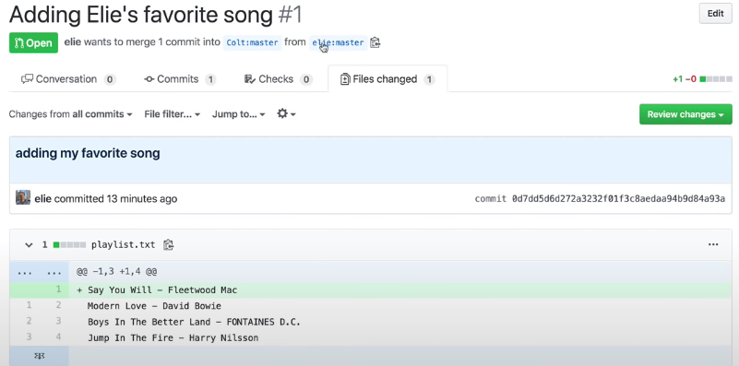
its coming from master branch of his fork.
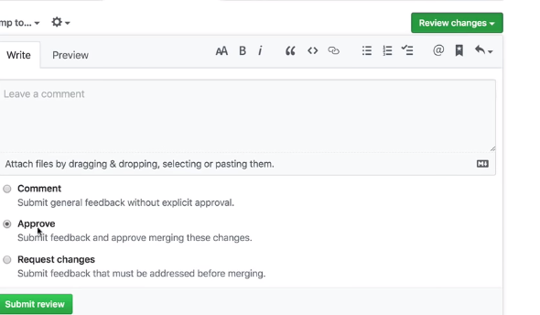
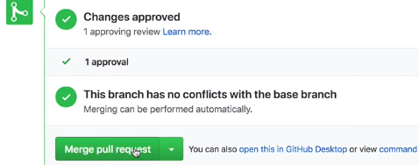

It worked.

